GO TO:
https://learningportal.hhs.texas.gov/course/index.php?categoryid=26
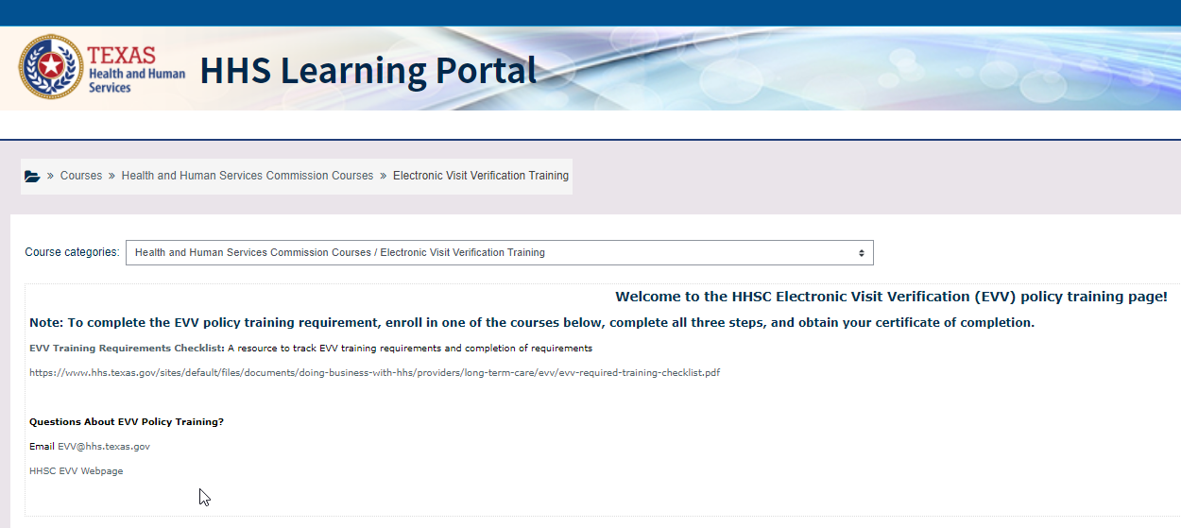
FOR ANNUAL TRAINING, SELECT:
LOG IN WITH CREDENTIALS CREATED FOR ACCOUNT FROM EMPLOYER’S INITIAL HHSC EVV POLICY TRAINING
SELECT:
- EVV POLICY TRAINING
- ENROLL ME
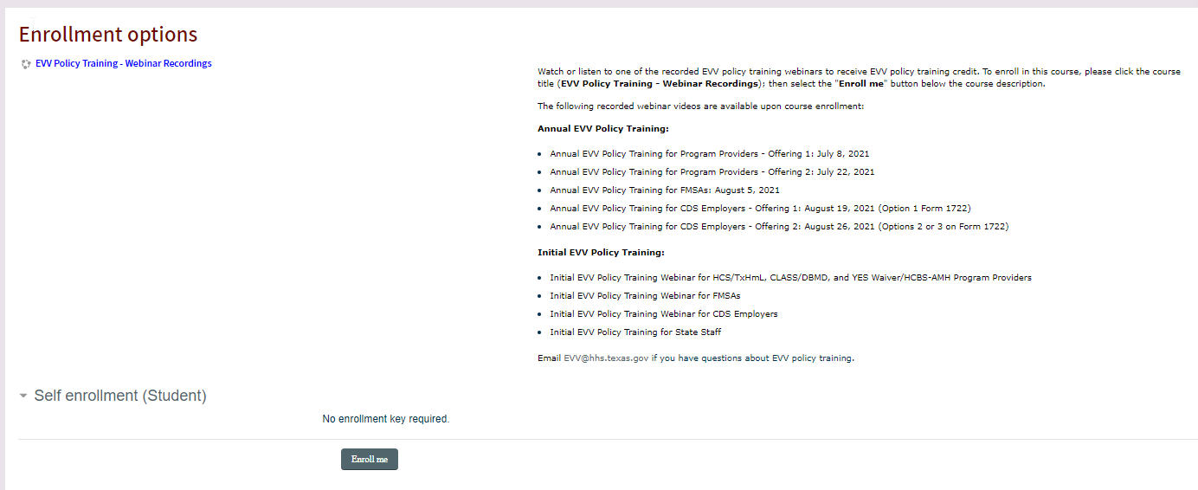

TO RECEIVE CREDIT FOR THIS EVV POLICY TRAINING AND OBTAIN YOUR CERTIFICATE OF COMPLETION, PLEASE COMPLETE EACH OF THE THREE STEPS:
- SELECT THE TRAINING VIDEO LINK BASED ON THE 1722 FORM OPTION CHOSEN BY EMPLOYER.
OPTION 1 ON 1722 FORM, SELECT TRAINING LINK BELOW:
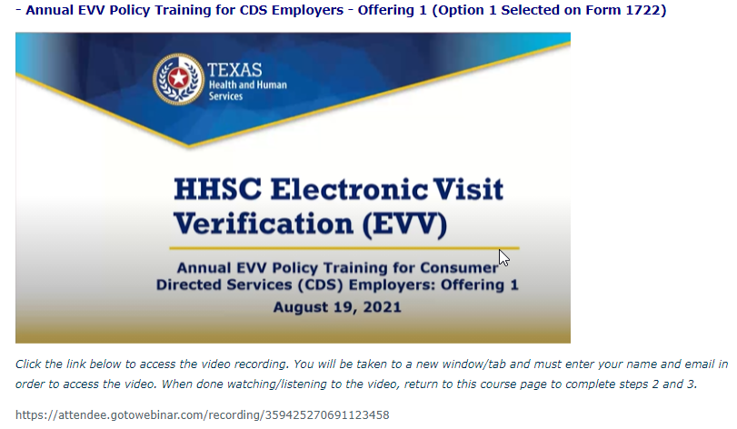

OPTION 2 & 3 ON 1722 FORM, SELECT TRAINING LINK BELOW:
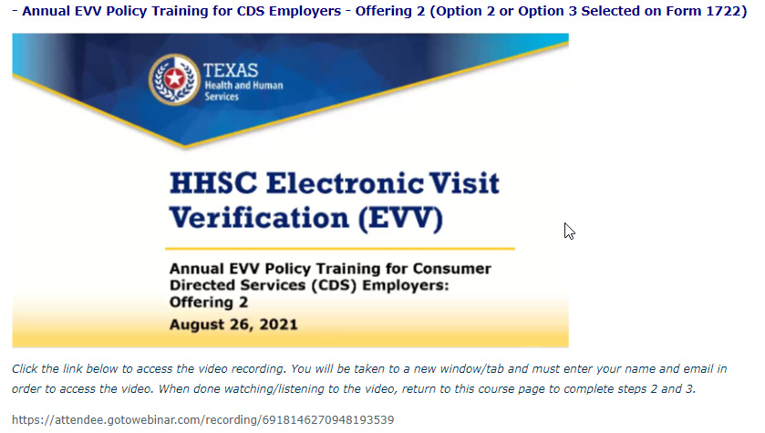

TO VIEW RECORDING, ENTER FIRST AND LAST NAME AND EMAIL ADDRESS AND SELECT REGISTER.

- TO CONFIRM THAT YOU REVIEWED THE VIDEO, CONFIRM ACKNOWLEDGEMENT BY ENTERING A CHECK MARK IN BOX BELOW:

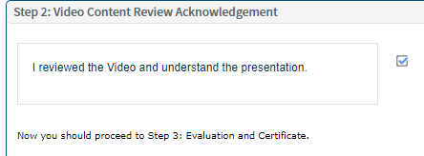

- EVALUATION AND CERTIFICATE

IN THIS FINAL STEP, COMPLETE AND SUBMIT THE COURSE EVALUATION BELOW, THEN YOU WILL BE ABLE TO ACCESS YOUR CERTIFICATE OF COMPLETION.
